Graphic  Instructions: To post on your social media channels, right click on the Graphic and click ‘Save as Picture’ and upload to your Twitter, Facebook, or Instagram. Simply copy & paste the corresponding caption to complete the post. | Caption
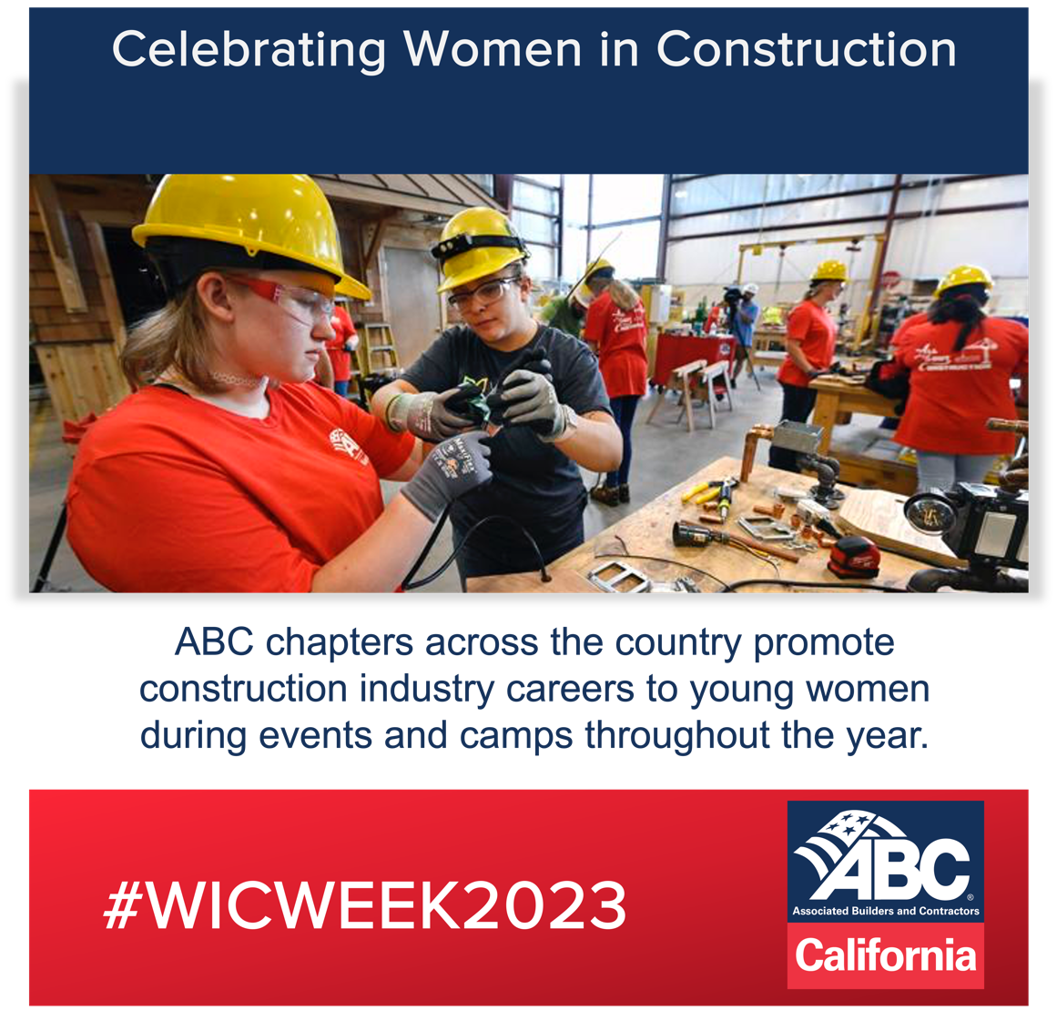 | ABC of California is #ABCMeritShopProud of the great work from our chapter and other chapters across the country for providing opportunities to inspire the next generation of #WomenInConstruction. Chapter staff, member volunteers and craft trainees mentor young women and inspire learning. Learn more: workforce.abc.org.
Graphic | Caption
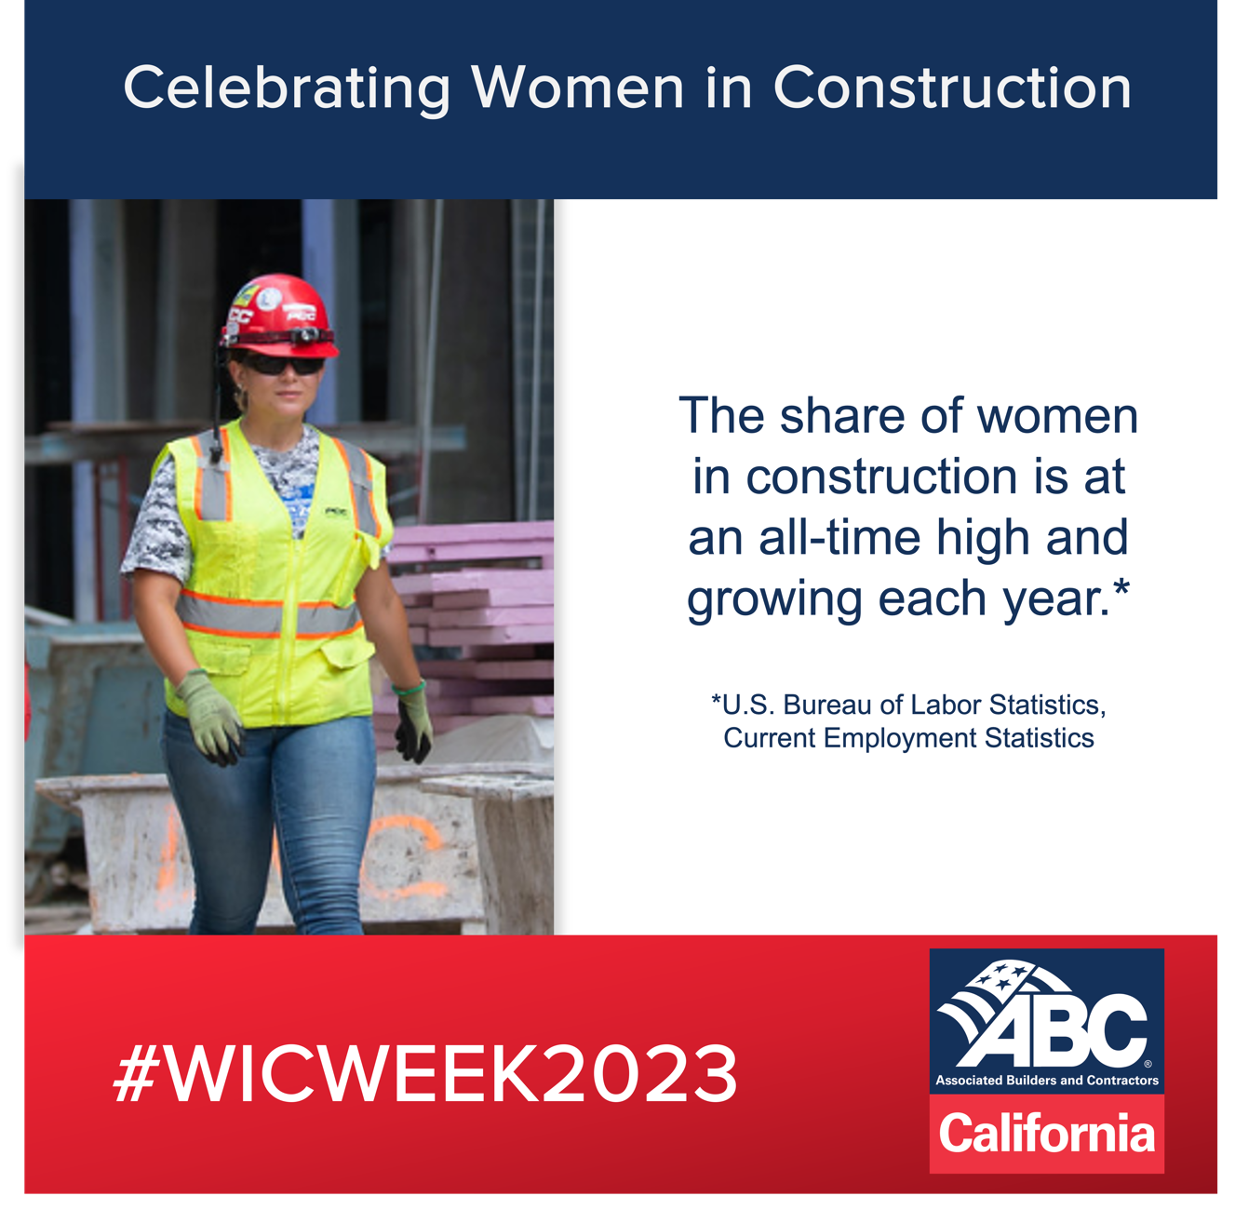 | A construction career offers limitless possibilities. #WomenInConstruction can find employment opportunities readily available and earn an income while they learn their craft. Learn more: workforce.abc.org #WICWeek2023 #ABCMeritShopProud
Graphic | Caption
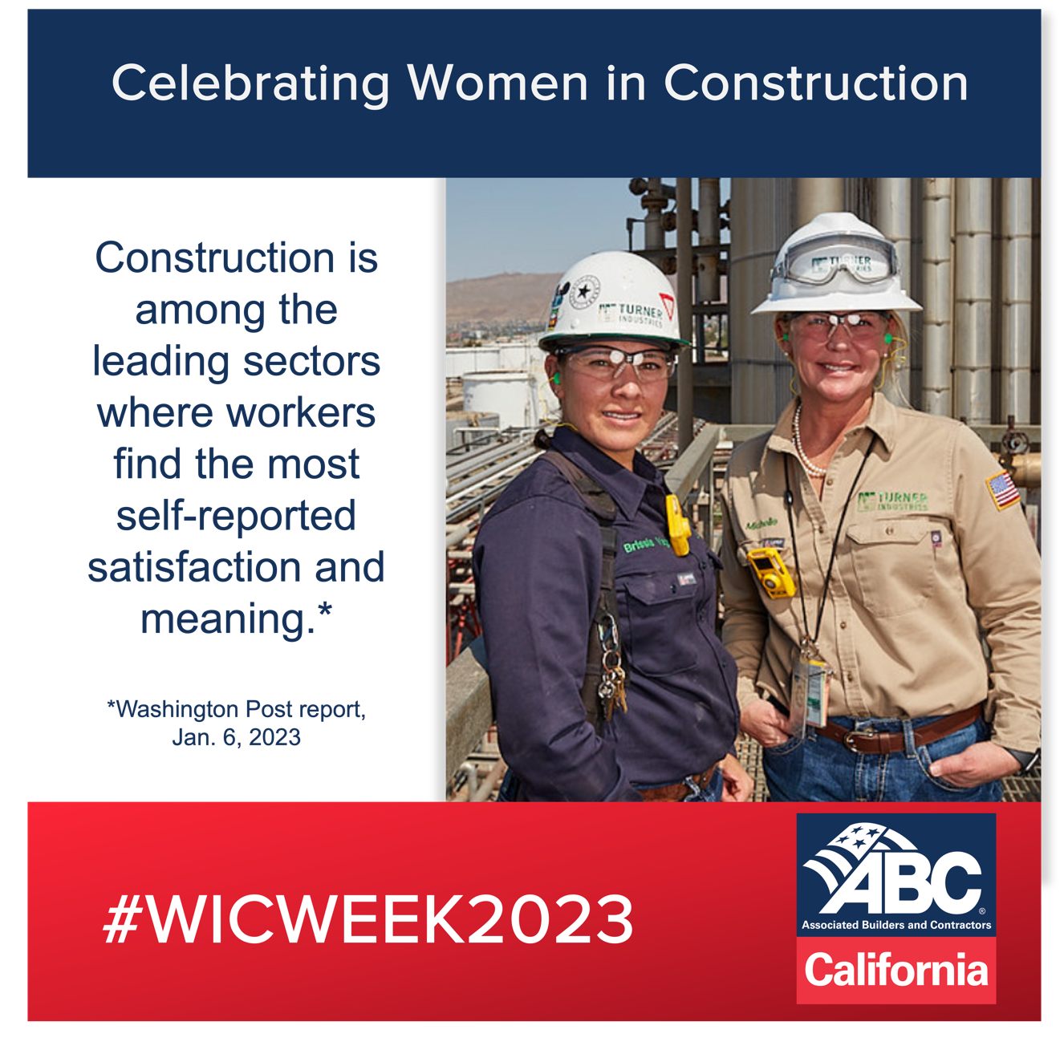 | #CareersInConstruction offer advancement and career mobility opportunities by creating pathways to meaningful work and fulfilling success. Begin your new career: workforce.abc.org #WICWeek2023 #ABCMeritShopProud
Graphic | Caption
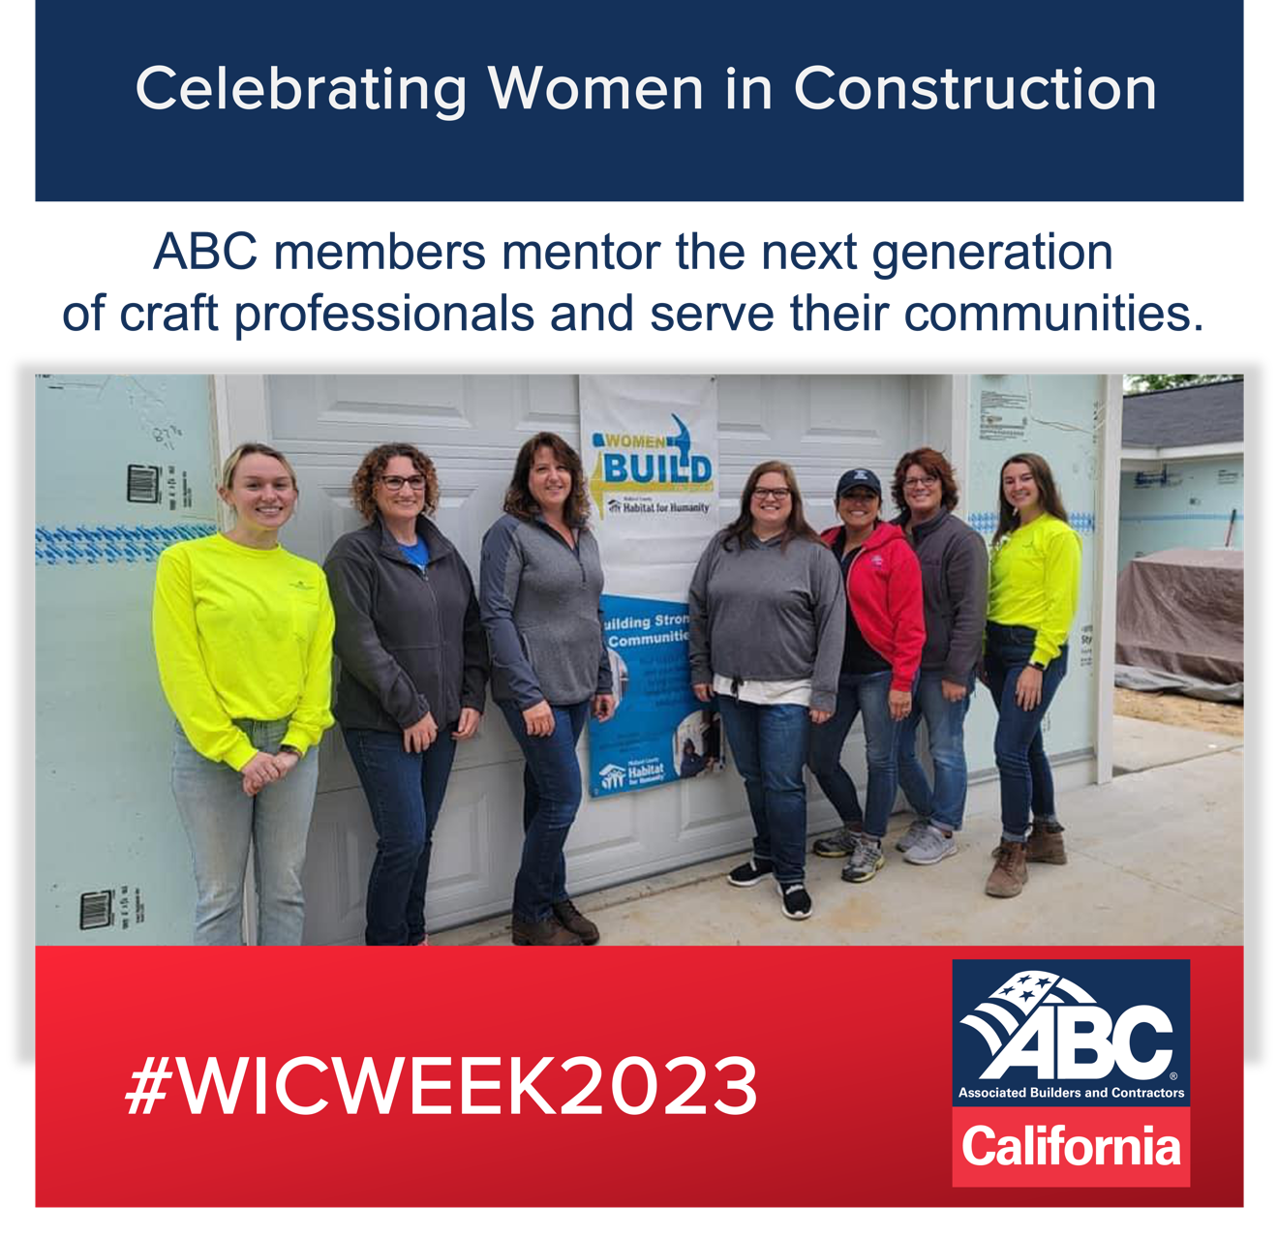 | #WomenInConstruction are leaders in their communities and participate in organizations that contribute to the betterment of the communities in which they work. Discover your career pathway at workforce.abc.org #WICWeek2023 #ABCMeritShopProud
Graphic | Caption
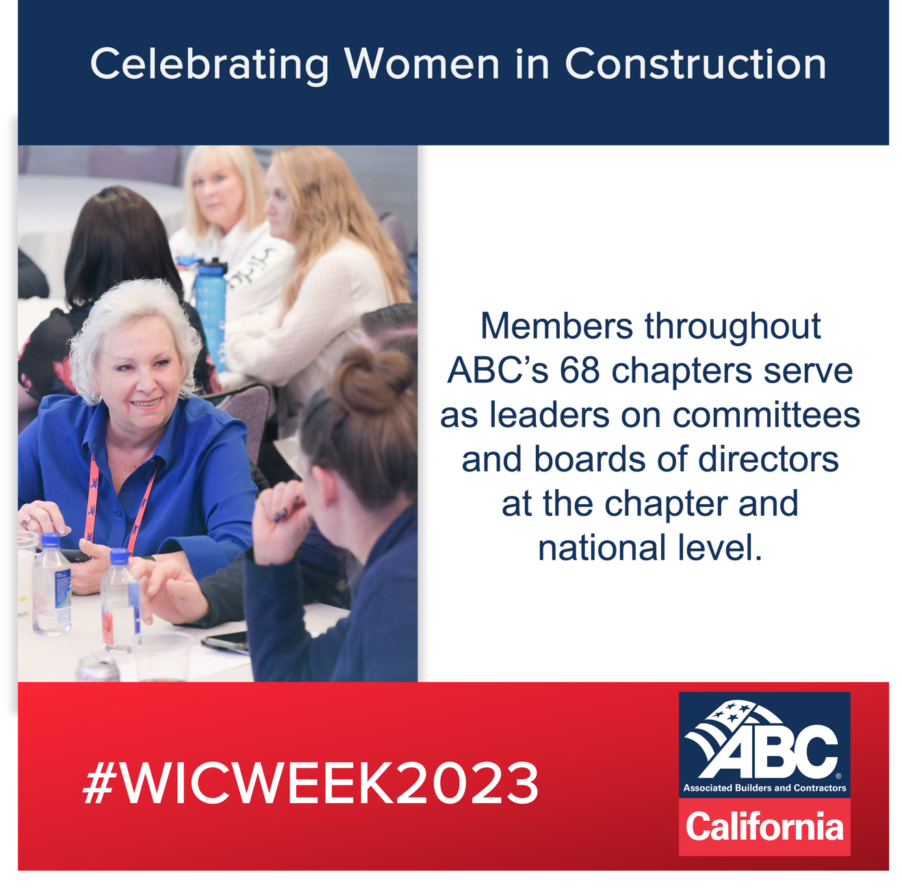 | ABC honors all #WomenInConstruction who serve as leaders across the country in the field and in the office. A career in the industry provides job satisfaction and lifetime accomplishments. Find your path to success: workforce.abc.org. #ABCMeritShopProud

